***Shifting home from Brooklyn to Queens Dilemma***

# Introduction

Person X Hailing from Brooklyn Heights, has got an offer from company in Queens, NY. He wants to understand if he would find neighbourhoods similar to Brooklyn Heights in Queens and if so which Places would be best for him to rent a new home. He seeks help of a Data Analyst to find out the answers for his questions.

# Data Collection

The New York maps data with 5 Boroughs is downloaded from <https://cocl.us/new_york_dataset>

Snap Shot of the NY Data is as given below:

# Exploring the Data

A Visual Representation of the 306 Neighbourhoods are as below :

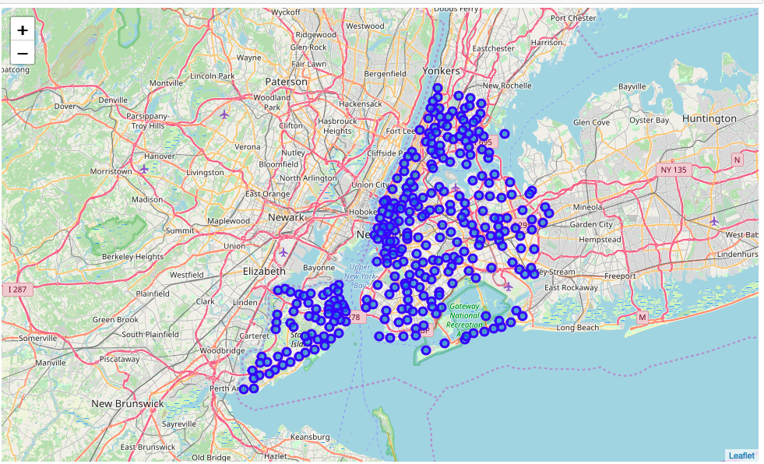

Figure 1. New York City Map plot with 5 Boroughs and 306 Neighbourhoods

A Visual Representation of the Brooklyn with Brooklyn Heights Highlighted

Figure 2. Visual representation of Brooklyn Heights.

A Visual Representation of the Queens Highlighted

Figure 3. Visual representation of Queens

A Visual Representation of the Brooklyn and Queens Highlighted

Figure 3. Visual representation of Brooklyn and Queens

# Comparing The Data With Venues obtained from four Square API & Conclusion

A visual Representation of Neighbourhoods that are similar to Brooklyn Heights in Queens.

Person X, Can move to any of the below Neighbourhoods of Queens

['Astoria' 'Woodside' 'Jackson Heights' 'Elmhurst' 'Howard Beach' 'Corona'

'Forest Hills' 'Kew Gardens' 'Richmond Hill' 'Flushing'

'Long Island City' 'Sunnyside' 'East Elmhurst' 'Maspeth' 'Ridgewood'

'Glendale' 'Rego Park' 'Woodhaven' 'Ozone Park' 'South Ozone Park'

'College Point' 'Whitestone' 'Bayside' 'Auburndale' 'Little Neck'

'Douglaston' 'Glen Oaks' 'Bellerose' 'Kew Gardens Hills' 'Fresh Meadows'

'Briarwood' 'Jamaica Center' 'Oakland Gardens' 'Queens Village' 'Hollis'

'South Jamaica' 'St. Albans' 'Rochdale' 'Springfield Gardens'

'Cambria Heights' 'Rosedale' 'Far Rockaway' 'Broad Channel' 'Steinway'

'Beechhurst' 'Bay Terrace' 'Edgemere' 'Arverne' 'Murray Hill'

'Floral Park' 'Holliswood' 'Jamaica Estates' 'Queensboro Hill'

'Hillcrest' 'Ravenswood' 'Lindenwood' 'Lefrak City' 'Rockaway Park'

'Bellaire' 'North Corona' 'Forest Hills Gardens' 'Jamaica Hills' 'Utopia'

'Pomonok' 'Astoria Heights' 'Hunters Point' 'Sunnyside Gardens'

'Blissville' 'Middle Village' 'Malba' 'Queensbridge']

